16. ReactJS-HOL:
Create a react with the name “mailregisterapp” & open it in the vs code.
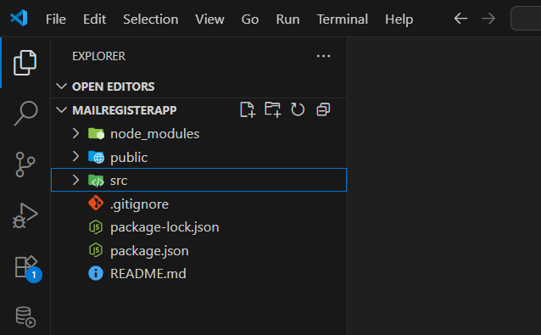
Create a Register component inside register.js file
Note: the component name should always start with the capital letter otherwise we will get es-lint warning.
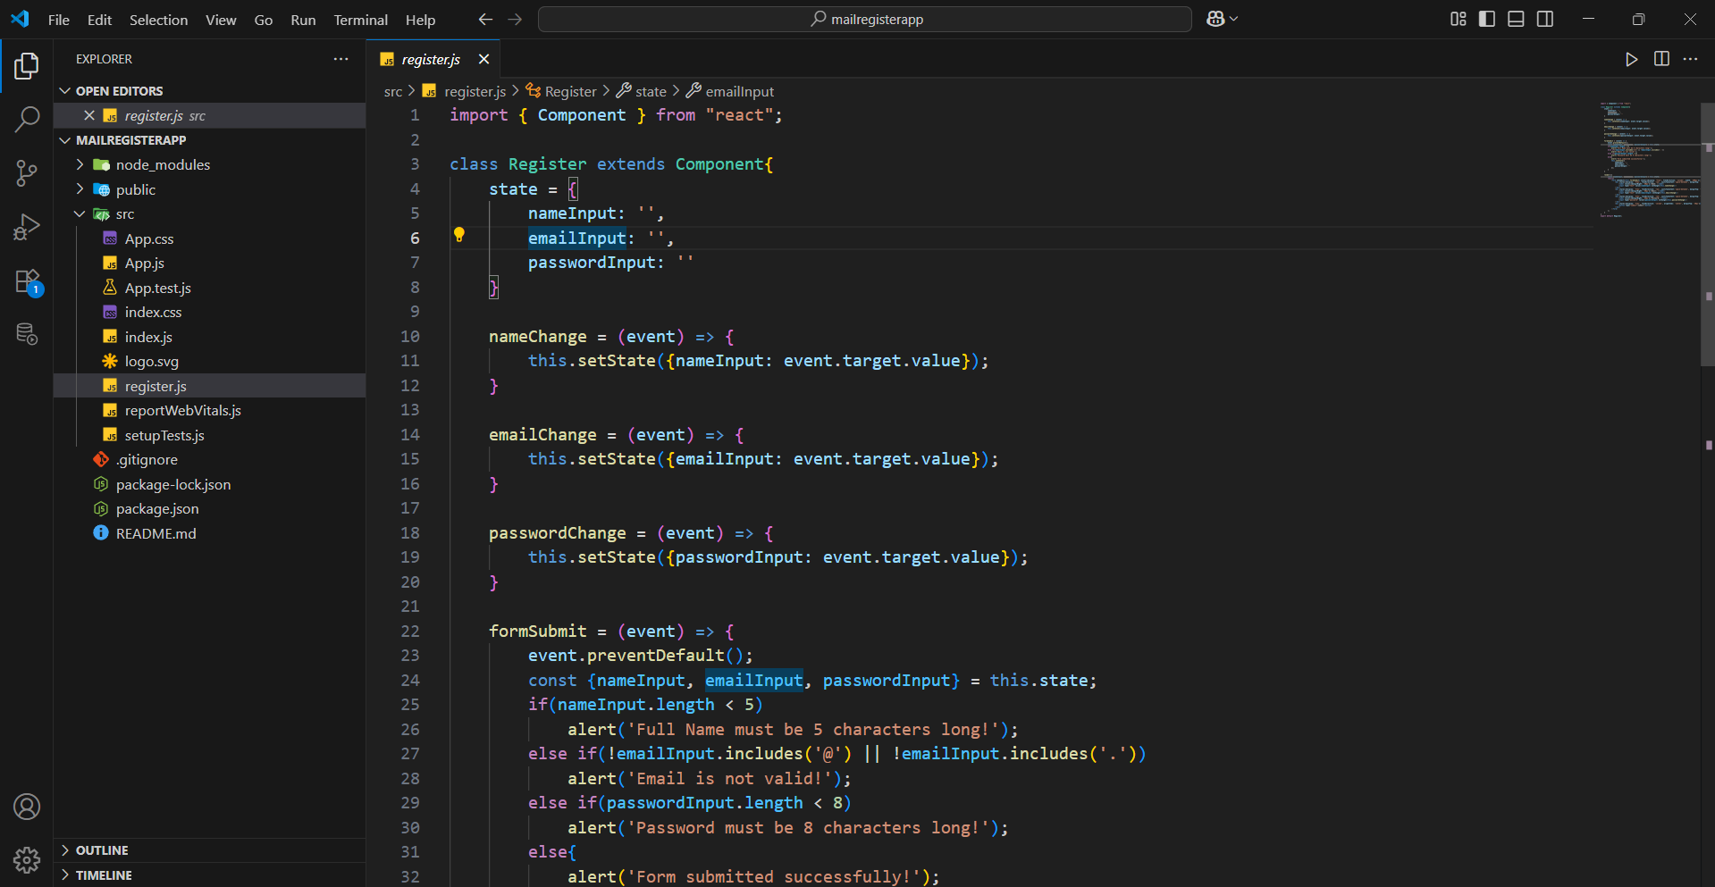
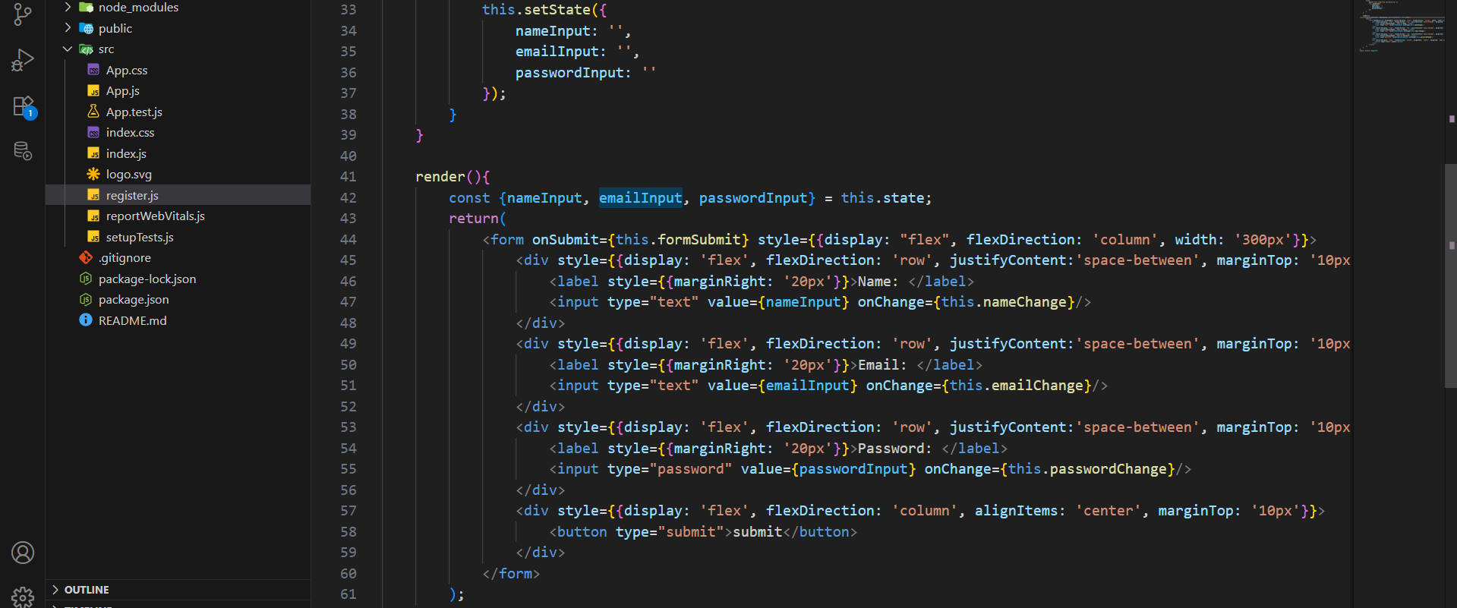
App component:
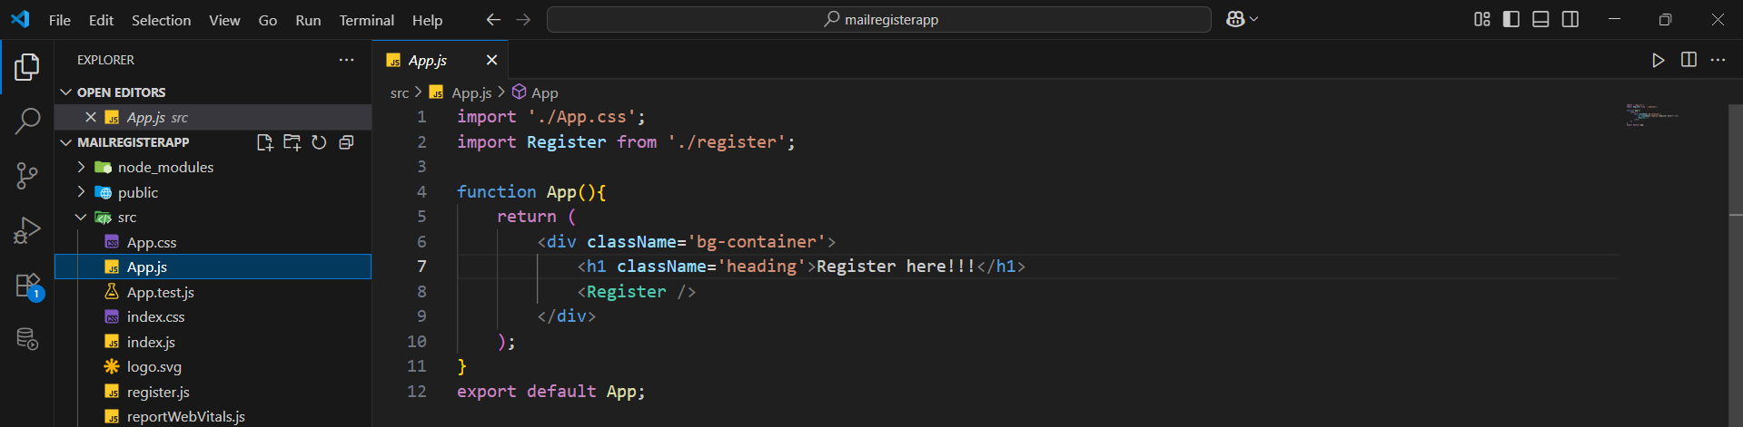
Output:
